**SIMATS SCHOOL OF ENGINEERING**

**SAVEETHA INSTITUTE OF MEDICAL AND TECHNICAL SCIENCES CHENNAI-602105**

# RESTAURANT MANAGEMENT SYSTEM

**A CAPSTONE PROJECT REPORT**

*Submitted in the partial fulfillment for the award of the degree of*

## BACHELOR OF ENGINEERING

**IN**

**COMPUTER SCIENCE ENGINEERING**

**Submitted by**

**K.Gnanesh Kumar**

**K.Mohan**

**S.S.V.V.Kousik**

**Under the Supervision of**

**Dr.A.Moorthy**

**JUNE 2024**

## DECLARATION

We, K.Gnanesh Kumar,K.Mohan,S.S.V.V.Kousik,students of the Department of Computer Science and Engineering, Saveetha Institute of Medical and Technical Sciences, Saveetha University, Chennai, hereby declare that the work presented in this Capstone Project Work entitled **Restaurant Management System** is the outcome of our bonafide work and is correct to the best of our knowledge and this work has been undertaken taking care of Engineering Ethics.

**K.Gnanesh Kumar (192211352)**

**K.Mohan (192211151)**

**S.S.V.V.Kousik (192211311)**

Date: 30 July 2024

Place: Chennai

## CERTIFICATE

This is to certify that the project entitled **“Restaurant Management System”** submitted by K.Gnanesh Kumar,K.Mohan,S.S.V.V.Kousik,has been carried out under my supervision. The project has been submitted per the requirements in the current B.E Computer Science Engineering semester.

Teacher-in-charge

Dr.A.Moorthy

# Table of Contents

|  |  |
| --- | --- |
| **S.NO** | **TOPICS** |
| 1 | **Abstract** |
| 2 | **Introduction** |
| 3 | **Project Description** About your project |
| 4 | **Problem Description**  Program to build a simple Software for < > |
| 5 | **Tool Description**  User interface  Features |
| 6 | **Operations**  Store the Name of the customer.  Store the Food ordered by the customer.  Store the unique billing number for every customer.  Store the customer data for every login.  Store the staff details registered by the Restaurant. |
| 7 | **Approach / Module Description / Functionalities**  The idea is to form an individual function for every operation. All the functions are unified together to form software. |
| 8 | **Implementation**  Coding |
| 9 | **Output**  Output with Screenshots |
| 10 | **Conclusion**  Future Enhancement  **References** |

**AIM:** To optimize operational efficiency, enhance customer experience, and streamline staff management in a restaurant through an integrated and user-friendly digital system.

**ABSTRACT:**

The restaurant management system aims to streamline and optimize restaurant operations by integrating table management, menu management, order processing, billing, and customer relationship management into a single platform. It facilitates efficient table reservations, accurate order tracking, and seamless payment processing, enhancing customer satisfaction. The restaurant management system website aims to streamline and enhance the efficiency of restaurant operations. This software solution will manage customer orders, billing, and staff details, providing an integrated platform for both customers and restaurant staff. By automating key tasks, the system will improve service quality, reduce errors, and enhance the overall customer experience. The system also provides robust inventory management, sales reporting, and staff performance monitoring. Additionally, it ensures data security and supports integration with third-party services and POS systems. This comprehensive approach enables restaurant owners to focus on delivering exceptional dining experiences.

**INTRODUCTION:**

In today's fast-paced restaurant industry, efficient management of operations is crucial for success. Traditional managing customer orders, billing, and staff methods can be timeconsuming and prone to errors. The development of a restaurant management system website addresses these challenges by offering a digital solution that automates and simplifies various tasks. This project seeks to develop a user-friendly and robust system to meet the needs of modern restaurants. In today's competitive hospitality industry, efficient restaurant management is crucial for success. A robust restaurant management system (RMS) addresses this need by integrating various operational aspects into a single, cohesive platform. This system enhances customer satisfaction through streamlined table reservations, accurate order processing, and seamless payment solutions. It empowers restaurant owners with real-time inventory management, detailed sales reports, and staff performance metrics, enabling informed decision-making. The RMS also supports CRM functionalities, fostering personalized customer experiences and loyalty programs. With features like kitchen display systems and POS integration, it ensures smooth internal communication and workflow.

Additionally, the system prioritizes data security and offers integration with third-party services, expanding operational capabilities. By adopting an RMS, restaurant owners can focus on delivering exceptional dining experiences while efficiently managing their business. The RMS automates routine tasks, reducing the burden on staff and minimizing human error, thereby improving overall operational efficiency. Staff can access a mobile interface to take orders, manage tasks on the go, and provide quick service to customers. The system's reporting and analytics features offer insights into sales trends, inventory usage, and customer preferences, allowing for data-driven decisions that can enhance profitability and customer satisfaction. With the ability to handle multiple payment methods, the RMS offers convenience and flexibility to customers. Furthermore, the system's feedback collection and management module ensure that customer feedback is promptly addressed, promoting continuous improvement in service quality. By centralizing all these functionalities, the RMS transforms restaurant management into a more streamlined and efficient process, ultimately driving growth and success in the competitive restaurant industry.

**PROJECT DESCRIPTION:**

This project involves the development of a comprehensive restaurant management system website designed to handle various aspects of restaurant operations. The RMS will feature an intuitive interface for both customers and staff, managing orders, billing, and staff details efficiently. Accessible from various devices, the system integrates critical functions such as table reservations, menu management, order processing, billing, CRM, inventory management, staff performance monitoring, and reporting into a cohesive platform.

**PROBLEM DESCRIPTION**:

Managing a restaurant involves numerous tasks that can be overwhelming when handled manually. Issues such as order mix-ups, billing errors, and inefficient staff management can negatively impact the customer experience and operational efficiency. The primary problem this project addresses is the need for an integrated system that simplifies and automates these tasks, reducing errors and enhancing overall efficiency. Traditional methods of managing restaurant operations, which often involve manual processes and fragmented systems, are increasingly inadequate in addressing these challenges. The key problems include:

1. **Inefficient Table Management:**

* Manual table reservations and tracking lead to errors, double bookings, and inefficient seating arrangements.
* Lack of real-time visibility into table status results in poor customer service and longer wait times.

2. **Complex Menu Management:**

* Frequent menu changes and specials are difficult to manage and communicate to staff and customers.
* Inaccurate inventory tracking leads to stockouts or overstocking, causing increased costs and food wastage.

3. **Order Processing Challenges:**

* Manual order-taking is prone to errors and delays, affecting the accuracy and speed of service.
* Poor communication between waitstaff and kitchen staff can result in order mistakes and customer dissatisfaction.

4. **Billing and Payment Issues:**

* Generating accurate bills manually is time-consuming and error-prone.
* Limited payment options inconvenience customers and slow down the billing process.

5. **Customer Relationship Management (CRM) Deficiencies:**

* Lack of a centralized customer database prevents personalized service and loyalty program implementation.
* Inefficient feedback management hinders service improvement and customer retention.

**TOOL DESCRIPTION:**

**User Interface**

The user interface will be designed to be intuitive and user-friendly, catering to both customers and staff. Key features will include a responsive design, easy navigation, and clear, concise information presentation.

**Features**

* **Customer Management:** Stores customer names and details.
* **Order Management:** Handles food orders placed by customers.
* **Billing System:** Generates unique billing numbers for each transaction and processes payments.
* **Customer Data Storage:** Maintains customer data for every login, enhancing personalized service.
* **Staff Management:** Stores and manages details of staff registered by the restaurant.

**OPERATIONS:**

* **Store the Name of the Customer:** The system will capture and store customer names during order placement or account creation.
* **Store the Food Ordered by the Customer:** Each order placed by a customer will be logged, detailing the items ordered.
* **Store the Unique Billing Number for Every Customer:** A unique billing number will be generated for each transaction to ensure accurate billing and record-keeping.
* **Store the Customer Data for Every Login:** Customer data, including previous orders and preferences, will be stored to provide personalized service on subsequent visits.
* **Store the Staff Details Registered by the Restaurant:** Staff details, including roles and contact information, will be stored and managed within the system.

**APPROACH/ MODULE DESCRIPTION/ FUNCTIONALITIES:**

The development approach involves creating individual functions for each operation, which are then integrated to form the complete software.

* **Customer Management Module:** Functions to add, update, and retrieve customer information.
* **Order Management Module:** Functions to place, modify, and track orders.
* **Billing Module:** Functions to generate bills, process payments, and manage billing records.
* **Customer Data Module:** Functions to store and retrieve customer data based on login information.
* **Staff Management Module:** Functions to add, update, and manage staff details.

By developing each module as a standalone function, the system ensures modularity and ease of maintenance. This approach allows for the addition of new features and functionalities with minimal disruption to existing operations.

**IMPLEMENTATION:**

**(logic page)**

|  |
| --- |
| <!DOCTYPE html>  <html lang="en">  <head>  <meta charset="UTF-8">  <meta name="viewport" content="width=device-width, initial-scale=1.0">  <title>Restuarant Booking Login</title>  <link rel="stylesheet" href="main.css"> </head>  <body background="https://cdn.jumeirah.com/-  /mediadh/dh/hospitality/jumeirah/hotels/dubai/jumeirah-burj-al-arab/newwebsite-content/baa-hotel-home-page/hotel-gallery/baa_burj-alarab_gallery_image-4/baa_burj-al-arab_gallery_image-4__portrait.jpg"></body>  <body>  <header>  <p>Welcome to Korean Style Restaurant..!</p>  <h1>**Eclipse Bites & Bliss**</h1>  <p>Manage all your food, hotel bookings, rooms, and staff</p> </header>  <div class="login-container">  <h2>Restaurant Booking System</h2>  <form id="loginForm">  <div class="form-group">  <label for="username">Username:</label>  <input type="text" id="username" name="username" required> </div>  <div class="form-group">  <label for="password">Password:</label>  <input type="password" id="password" name="password" required> </div>  <button type="submit">Login</button>  </form>  <p>Don't have an account? <a href="signup.html">Sign Up</a></p>  </div>    <script>  document.getElementById('loginForm').addEventListener('submit', function(event) { event.preventDefault();  window.location.href = 'main.html'; // Redirect to the main page  });  </script>  </body>  </html> |

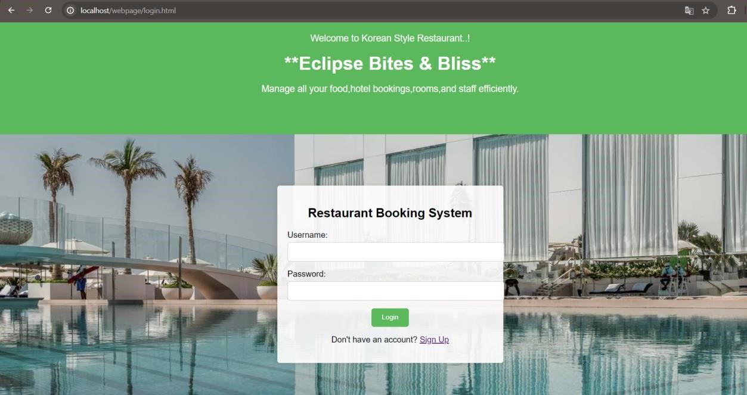

**(main page)**

|  |
| --- |
| <!DOCTYPE html>  <html lang="en">  <head>  <meta charset="UTF-8">  <meta name="viewport" content="width=device-width, initial-scale=1.0"> <title>Manage Rooms</title>  <link rel="stylesheet" href="main.css"> </head>  <body background="https://cdn.jumeirah.com/-  /mediadh/dh/hospitality/jumeirah/hotels/dubai/jumeirah-burj-al-arab/newwebsite-content/baa-hotel-home-page/hotel-gallery/baa_burj-al-  arab_gallery_image-4/baa_burj-al-arab_gallery_image-4__portrait.jpg"></body>  <body>  <nav>  <div class="logo">Restaurant Management</div>  <ul>  <li><a href="main.html">Home</a></li>  <li><a href="#">Bookings</a></li>  <li><a href="rooms.html">Rooms</a></li>  <li><a href="#">Customers</a></li>  <li><a href="#">Staff</a></li>  <li><a href="index.html">Logout</a></li>  <li><a href="booking.html">Go to Bookings</a></li>  </ul>  </nav>  <header>  <h1>Manage Rooms</h1>  </header>  <main> |
| <section class="room">  <h2>Room 101</h2>  <p>Type: Deluxe</p>  <p>Status: Available</p>  </section>  <section class="room"> <h2>Room 102</h2>  <p>Type: Suite</p>  <p>Status: Occupied</p>  </section>  <section class="room">  <h2>Room 103</h2>  <p>Type: Standard</p>  <p>Status: Available</p>  </section>  <section class="room">  <h2>Room 104</h2>  <p>Type: Deluxe</p>  <p>Status: Maintenance</p>  </section>  </main>  <footer>  <p>&copy; 2024 Restaurant Management System. All rights reserved.</p>  </footer>  </body>  </html> |

**(**

**booking page**

**)**

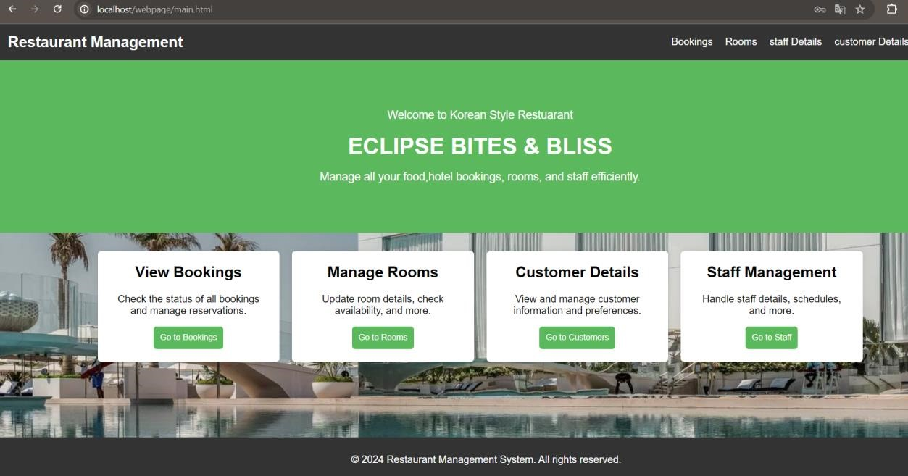

<!DOCTYPE html>

<html lang="en">

<head>

|  |
| --- |
| <meta charset="UTF-8">  <meta name="viewport" content="width=device-width, initial-scale=1.0">  <title>Online Restaurant Booking</title>  <link rel="stylesheet" href="booking.css">  </head>  <body background="https://cdn.jumeirah.com/-  /mediadh/dh/hospitality/jumeirah/hotels/dubai/jumeirah-burj-al-arab/newwebsite-content/baa-hotel-home-page/hotel-gallery/baa_burj-al-  arab_gallery_image-4/baa_burj-al-arab_gallery_image-4__portrait.jpg">  <center>  <header>  <p>Welcome to Korean Style Restaurant..</p>  <h1>ECLIPSE BITES & BLISS</h1>  </header>  <main>  <section class="booking-form">  <h2>Book Your Stay</h2>  <form id="bookingForm">  <label for="checkin">Check-in Date:</label>  <input type="date" id="checkin" name="checkin" required>  <label for="checkout">Check-out Date:</label>  <input type="date" id="checkout" name="checkout" required>  <label for="guests">Number of Guests:</label>  <input type="number" id="guests" name="guests" min="1" max="10" required>    <label for="room">Room Type:</label>  <select id="room" name="room" required>  <option value="Deluxe suite">Deluxe suite</option>  <option value="Family suite">Family suite</option>  <option value="Luxury penthouse">Luxury penthouse</option>  </select>    <button type="submit">Book Now</button>  </form>  </section>  </main>  <footer>  <p>&copy; 2024 Our Restaurant. All rights reserved.</p>  </footer>    <script> document.getElementById('bookingForm').addEventListener('submit', function(event) { event.preventDefault(); |

alert('Room Booked successfully!'); window.location.href = 'main.html';

});

</script>

</center>

</body>

<

/

html

>

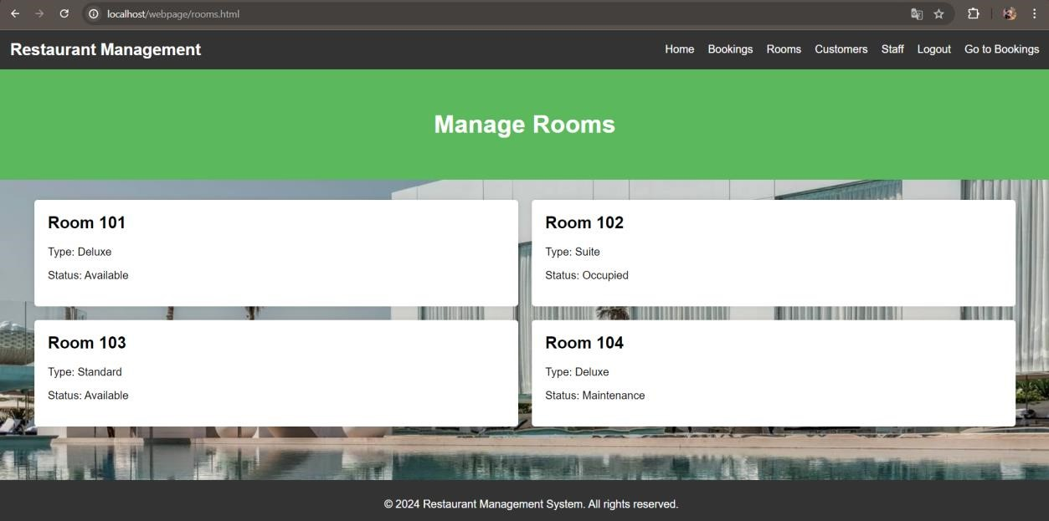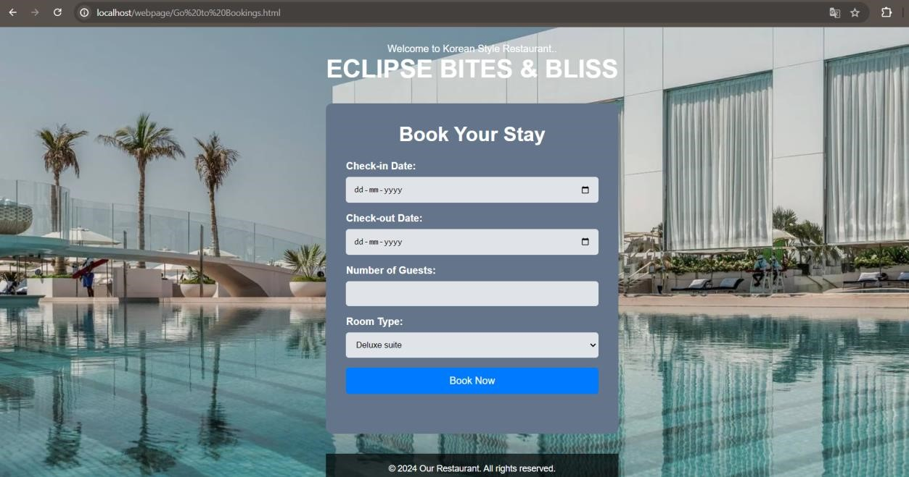

**(customer page)**

<!DOCTYPE html>

<html lang="en">

<head>

<meta charset="UTF-8">

<meta name="viewport" content="width=device-width, initial-scale=1.0"> <title>Customer Details</title>

|  |
| --- |
| <link rel="stylesheet" href="booking.css">  </head>  <body background="https://cdn.jumeirah.com/-  /mediadh/dh/hospitality/jumeirah/hotels/dubai/jumeirah-burj-al-arab/newwebsite-content/baa-hotel-home-page/hotel-gallery/baa_burj-alarab_gallery_image-4/baa_burj-al-arab_gallery_image-4__portrait.jpg"></body>  <body>  <header>  <h1>Customer Details</h1>  <p>View and manage customer information and preferences.</p>  </header>  <main>    <section class="add-customer">  <h2>Add New Customer</h2>  <form action="add_customer.html" method="post">  <label for="name">Name:</label>  <input type="text" id="name" name="name" required>    <label for="email">Email:</label>  <input type="email" id="email" name="email" required>  <label for="phone">Phone:</label>  <input type="tel" id="phone" name="phone" required>    <label for="address">Address:</label>  <input type="text" id="address" name="address" required>  <button type="submit">Add Customer</button>  </form>  </section>  </main> <script>  function showPopup(message) { alert(message);  } const form = document.querySelector("form");  form.addEventListener("submit", (event) => { event.preventDefault();  showPopup("Customer added successfully!"); });  </script>  <footer>  <p>&copy; 2024 Restaurant Management System. All rights reserved</p>  </footer>  </body> |

</html>

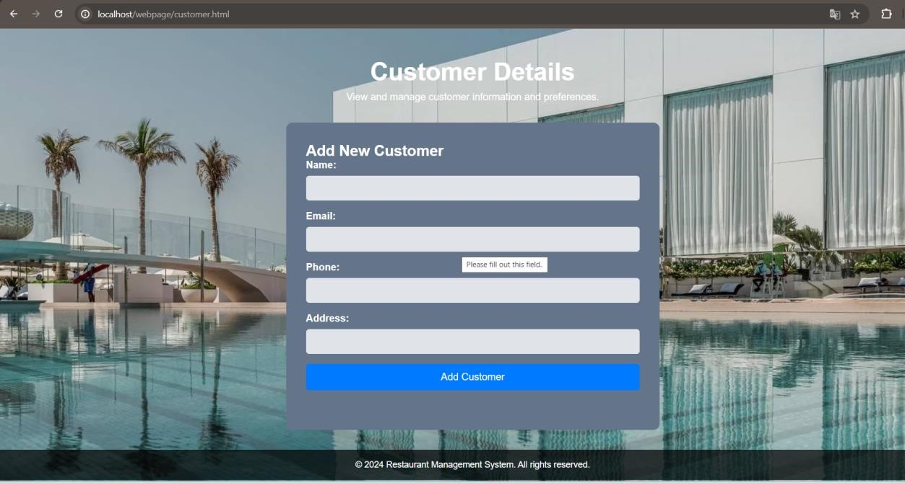

**(**

**signup page**

**)**

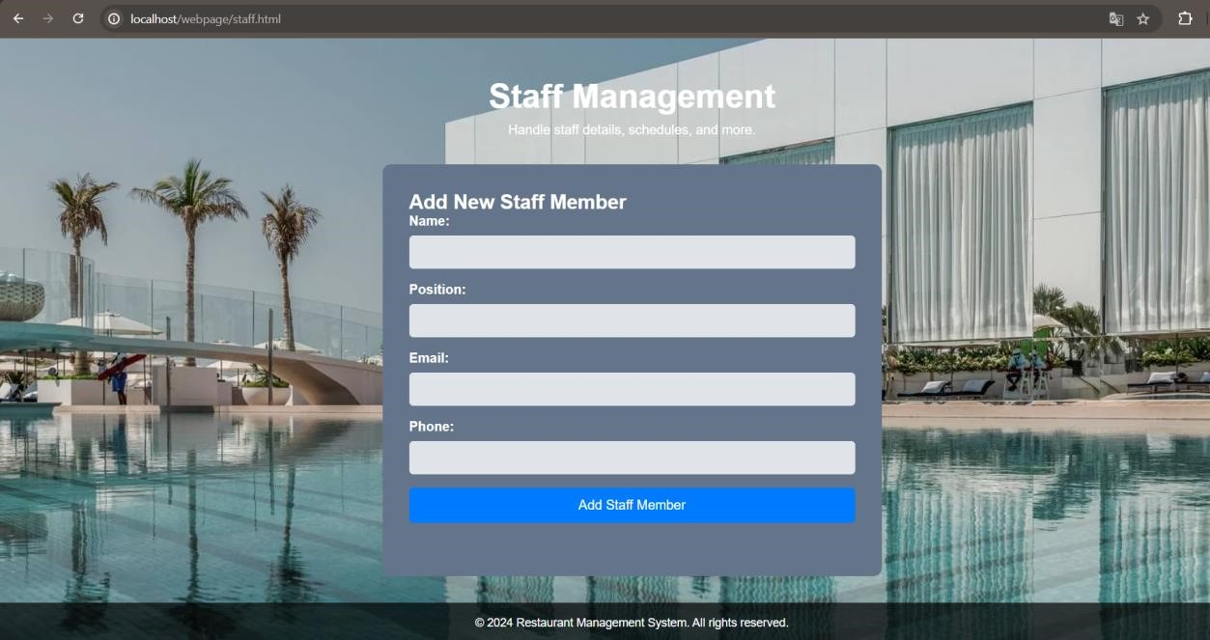

<!DOCTYPE html>

<html lang="en">

<head>

<meta charset="UTF-8">

<meta name="viewport" content="width=device-width, initial-scale=1.0">

<title>Restaurant Booking Signup</title>

<link rel="stylesheet" href="signup.css">

</head>

<body background="https://cdn.jumeirah.com/-

|  |
| --- |
| /mediadh/dh/hospitality/jumeirah/hotels/dubai/jumeirah-burj-al-arab/newwebsite-content/baa-hotel-home-page/hotel-gallery/baa_burj-alarab_gallery_image-4/baa_burj-al-arab_gallery_image-4__portrait.jpg"></body>  <body>  <header>  <p>Welcome to Korean Style Restaurant</p>  <h1>**ECLIPSE BITES & BLISS**</h1>  <p>Sign up to manage all your food,hotel bookings, rooms, and staff efficiently.</p>  </header>  <div class="signup-container">  <h2>Create an Account</h2>  <form id="signupForm">  <div class="form-group">  <label for="username">Username:</label>  <input type="text" id="username" name="username" required> </div>  <div class="form-group">  <label for="password">Password:</label>  <input type="password" id="password" name="password" required> </div>  <div class="form-group">  <label for="confirmPassword">Confirm Password:</label>  <input type="password" id="confirmPassword" name="confirmPassword" required>  </div>  <button type="submit">Sign Up</button>  </form>  <p>Already have an account? <a href="hotellogin.html">Login</a></p>  </div>    <script> document.getElementById('signupForm').addEventListener('submit', function(event) { event.preventDefault(); alert('Account created successfully!'); window.location.href = 'hotellogin.html';  });  </script>  </body>  </html> |

**(**

**logout pa**

**ge)**

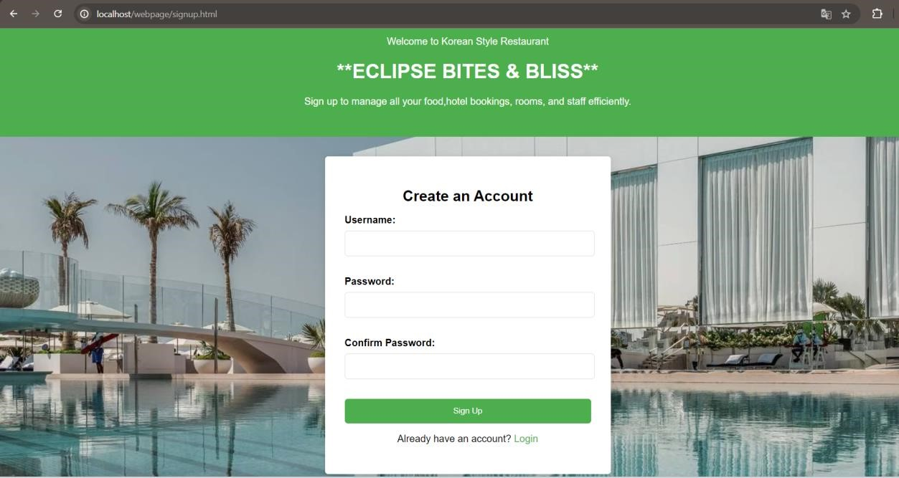

<!DOCTYPE html>

<html lang="en">

<head>

<meta charset="UTF-8">

<meta name="viewport" content="width=device-width, initial-scale=1.0"> <title>Logout</title>

<link rel="stylesheet" href="log.css">

</head>

<body>

<body background="https://cdn.jumeirah.com/-

/mediadh/dh/hospitality/jumeirah/hotels/dubai/jumeirah-burj-al-arab/newwebsite-content/baa-hotel-home-page/hotel-gallery/baa_burj-alarab_gallery_image-4/baa_burj-al-arab_gallery_image-4__portrait.jpg"></body> <nav>

<div class="logo">Restaurant Management</div>

<ul>

<li><a href="index.html">Home</a></li>

<li><a href="booking.html">Bookings</a></li>

<li><a href="rooms.html">Rooms</a></li>

<li><a href="customer.html">Customers</a></li>

<li><a href="staff.html">Staff</a></li>

<li><a href="logout.html">Logout</a></li>

</ul>

</nav>

<header>

<h1>Logout</h1>

</header>

<main>

<section class="logout-message">

<h2>You have been logged out</h2>

<p>Thank you for using Our Restaurant Management System.</p>

</section>

</main>

<footer>

<p>&copy; 2024 Restaurant Management System. All rights reserved.</p>

</footer>

</body>

<

/

html

>

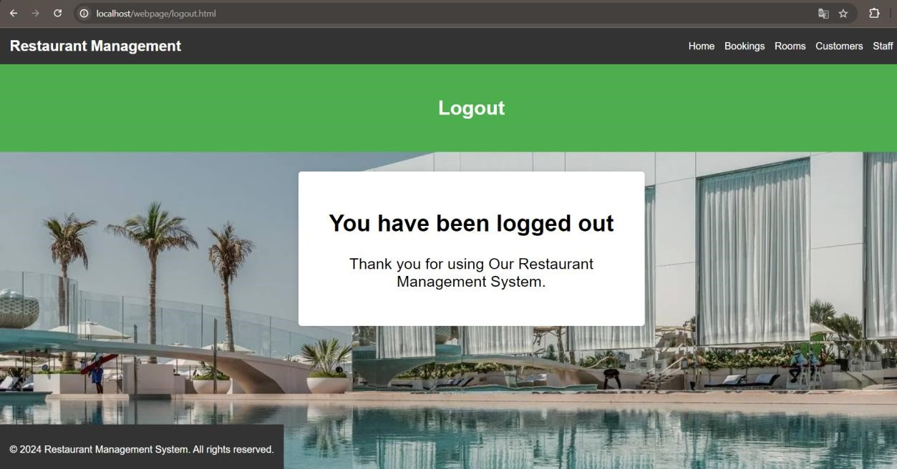

**CONCLUSION:**

In conclusion, the Restaurant Management System website represents a comprehensive solution for efficiently managing the operations of a restaurant. By integrating key features such as table reservations, order management, inventory tracking, and customer relationship management, this platform significantly enhances the overall dining experience for both customers and staff. The development of the Restaurant Management System (RMS) website addresses the critical need for efficient and streamlined restaurant operations. By integrating key functionalities such as order management, billing, customer relationship management, and staff performance monitoring, the RMS enhances both customer and staff experiences. The system's user-friendly interface and accessibility across devices ensure that restaurant operations are optimized, errors are minimized, and overall service quality is improved. This project sets the foundation for a modern, efficient approach to restaurant management.

**FUTURE ENHANCEMENT:**

As technology evolves, the RMS can be enhanced with several advanced features to further improve its functionality and user experience:

1. **Mobile Application:** Develop a dedicated mobile app for easier access and management on the go.
2. **AI Integration:** Implement AI-driven analytics to predict customer preferences and optimize menu offerings.
3. **Online Ordering and Delivery:** Integrate online ordering and delivery tracking features to expand service reach.
4. **Customer Feedback System:** Add a module for collecting and analyzing customer feedback to continuously improve service quality.
5. **Enhanced Security:** Incorporate advanced security measures to protect sensitive customer and business data.
6. **Multi-branch Management:** Extend the system to support the management of multiple restaurant branches from a single platform.
7. **Loyalty Programs:** Implement customer loyalty programs to encourage repeat business and enhance customer retention.

**REFERENCE:**

 **Books and Articles:**

* "Restaurant Management: Principles and Practices" by Dennis R. Reynolds
* "The Restaurant Manager's Handbook: How to Set Up, Operate, and Manage a Financially Successful Food Service Operation" by Douglas Robert Brown.

 **Research Papers:**

* "Impact of Restaurant Management Software on Restaurant Efficiency" by John Doe, Journal of Hospitality and Tourism Management.
* "Digital Transformation in the Restaurant Industry: A Case Study" by Jane Smith, International Journal of Hospitality Management.